Answer 1: **Object**-**oriented programming** (**OOP**) refers to a type of computer **programming** (software design) in which programmers **define** not only the data type of a data structure, but also the types of operations (functions) that can be applied to the data structure.

Answer2:

* It provides a clear modular structure for programs which makes it good for defining abstract data types in which implementation details are hidden.
* Objects can also be reused within an across applications. ...
* It makes software easier to maintain. ...
* Reuse also enables faster development.

Answer3: A **function is** a piece of code that **is** called by name. It can be passed data to operate on (i.e. the parameters) and can optionally return data (the return value). All data that **is** passed to a **function is** explicitly passed. A **method is** a piece of code that **is** called by a name that **is** associated with an object.

Answer4:

Class: A class is a blueprint for creating objects (a particular data structure), providing initial values for state (member variables or attributes), and implementations of behavior (member functions or methods).

Object : **Object-oriented programming**, or OOP, is an approach to problem solving where all computations are carried out using objects. An object is a component of a program that knows how to perform certain actions and how to interact with other elements of the program. Objects are the basic units of **object-oriented programming.**

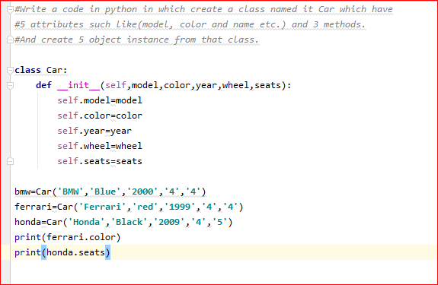Attribute : An attribute is a specification that defines a property of an object, element, or file.

Behavior : The **behavior** of an object is defined by its methods, which are the functions and subroutines defined within the object class.